

# Meta-skills Development Log

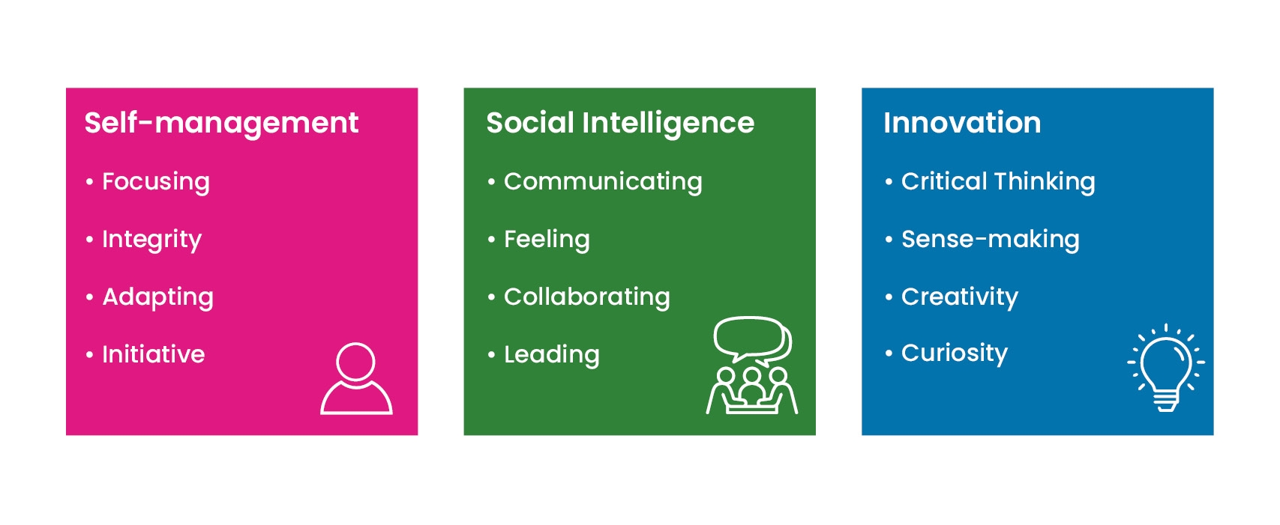

This development log includes prompts for each of the evidence requirements within the meta-skills outcome in your Higher National (HN) course.

Download and save the document to your files.

Fields can be completed and updated over the course of the year.

| **Name** | **Course** |
| --- | --- |
|  |  |

**Meta-skills outcome:** Develop meta-skills in a vocational or academic context.

The meta-skills outcome is included within a mandatory unit in your course. You can produce evidence within this unit and from any other relevant activities and experiences across the entire course.

## Outcome evidence requirements

You must produce evidence to show you can:

1. Self-assess your meta-skills baseline.
2. Create a plan to develop your own meta-skills.
3. Carry out activities to develop and demonstrate your meta-skills.
4. Use reflective practice to monitor and assess the meta-skills you have improved and developed.

## Resources to support your meta-skills development

There are further resources available on the [SQA NextGen: HN website.](https://www.sqa.org.uk/sqa/110308.html) Use the dropdown ‘Learner’ menu on the meta-skills page to access:

* SQA Academy learner modules: Introducing Meta-skills, Understanding Meta-skills, Developing Meta-skills — these contain lots of advice and activities to help you generate evidence for the meta-skills outcome.
* Meta-skills Assessment and Grading Information for learners.
* Meta-skills — advice on stepping up from Higher National Certificate (HNC) to Higher National Diploma (HND) for learners.

### What type of learner are you?

If you are new to meta-skills, or if you have quite recently left school, you might be best to take a course focus. What skills do you need to develop for success in your course?

If you are progressing from HNC to HND, you should continue to build on your meta-skills development. The meta-skills outcome is the same at HNC and HND, so the starting point for your skills development can follow on from your work in the previous academic year.

Learners with experience of meta-skills and those who come from previous employment are likely to have a clear sense of the transferable skills they already have. To make the meta-skills work as meaningful as possible, connect it to your plans for next year and beyond. Look at the national standards, competencies or values which underpin your industry, university course specs, or job adverts — whatever is appropriate. What transferable skills are they looking for? How might you use the meta-skills outcome this year to build upon your skills and strengthen your applications?

## Evidence requirement 1: baseline self-assessment

The baseline self-assessment asks you to reflect on how you view your meta-skills near the beginning of the development process, creating a benchmark to help you to set goals, plan actions and reflect on progress in your skills development across the year.

In your baseline reflections, consider your personal strengths and areas for development. You need to take an analytical approach, connecting this self-assessment to things like:

* previous experiences (including work, study, interests, etc)
* aspects of self (such as behaviours, skills, traits, preferences, motivations)
* skills aligned with your course and your professional ambitions
* confidence statements (for example confident / very confident) or ratings (for example out of 10)

You have two options for doing this; whicheverapproach you prefer, you must cover at least three of the meta-skills in each category.

**Option A:** baseline self-assessment by broadly considering each category:

| **Category** | **Reflect on your experience, confidence or abilities** |
| --- | --- |
| **Self-management** |  |
| **Social Intelligence** |  |
| **Innovation** |  |

**Option B:** baseline self-assessment on a skill-by-skill basis:

Self-management

| **Skill** | **Reflect on your experience, confidence or abilities** |
| --- | --- |
| **Focusing** |  |
| **Integrity** |  |
| **Adapting** |  |
| **Initiative** |  |

Social Intelligence

| **Skill** | **Reflect on your experience, confidence or abilities** |
| --- | --- |
| **Communicating** |  |
| **Feeling** |  |
| **Collaborating** |  |
| **Leading** |  |

Innovation

| **Skill** | **Reflect on your experience, confidence or abilities** |
| --- | --- |
| **Critical Thinking** |  |
| **Sense-making** |  |
| **Creativity** |  |
| **Curiosity** |  |

## Evidence requirements 2, 3, 4: plans, activities, reflective practice

You will set and monitor three goals to develop meta-skills which, as a collection, cover the three categories of: self-management, social intelligence, and innovation.

This section of the log is organised goal-by-goal, giving you space to describe and monitor each one.

Create a plan — set goals and intended actions:

* Your goals should connect to your baseline self-reflections. They should build on your strengths, target areas for development, and connect to your studies and/or vocational area.
* You should plan steps to work towards your meta-skills development goals. These steps can highlight actions, behaviours, ways of working and course activities which you think will help you to develop and demonstrate your meta-skills.

Carry out activities:

* Over the course of the year, keep a note of the activities (planned and unplanned) which have helped you to develop your meta-skills. This forms the basis of your reflective practice.

Use reflective practice:

* You will reflect on these activities to monitor your own meta-skills development. You can do this on a regular basis or at a couple of points around the middle and end of the academic year.
* Remember, as your goals cover all three categories of meta-skills, so should your reflections.
* You need to take an analytical approach to your reflective practice. This means clearly demonstrating how your experiences or course activities have influenced your meta-skills development, or how your meta-skills have helped you to successfully manage the requirements of your course.

## Development goal 1

**What kind of goal is this?**

| **Select ONE of the following:** | **Mark with a cross (X)** |
| --- | --- |
| Focus on a specific meta-skill |  |
| Target multiple skills within a category |  |
| Broader personal goals connecting to a number of skills / categories |  |

### Outline your specific goal

| **What do you want to achieve?** |
| --- |
|  |

### What meta-skills development will this goal target?

| **Skills** | **Mark with a cross (X)** |
| --- | --- |
| Focusing |  |
| Integrity |  |
| Adapting |  |
| Initiative |  |
| Communicating |  |
| Feeling |  |
| Collaborating |  |
| Leading |  |
| Curiosity |  |
| Creativity |  |
| Sense-making |  |
| Critical Thinking |  |

### Outline your planned actions

| **What actions will you take towards your goal?** |
| --- |
|  |

| **What strategies will you try?** |
| --- |
|  |

| **What opportunities might you have from the course content and work?** |
| --- |
|  |

### Monitor development opportunities

| **Over the course of the year, record the course activities or experiences that have helped toward your goal.** |
| --- |
|  |

### Record or reference your reflections relating to this goal

**How have your experiences helped you to develop and demonstrate your meta-skills? And, how have meta-skills helped you to meet the requirements of your course?**

Your reflections can either be recorded at arranged points — such as a mid-point and  
end-point review. Or, as shorter ‘in the moment’ reflections undertaken on a more regular basis. You can add your reflections here or include a note of any reflections stored elsewhere, for example: referencing annotations, feedback, voice notes, vlogs, journal, etc.

| **Mid-point or ongoing reflection** |
| --- |
|  |

| **End-point reflection** |
| --- |
|  |

## Development goal 2

**What kind of goal is this?**

| **Select ONE of the following:** | **Mark with a cross (X)** |
| --- | --- |
| Focus on a specific meta-skill |  |
| Target multiple skills within a category |  |
| Broader personal goals connecting to a number of skills / categories |  |

### Outline your specific goal

| **What do you want to achieve?** |
| --- |
|  |

### What meta-skills development will this goal target?

| **Skills** | **Mark with a cross (X)** |
| --- | --- |
| Focusing |  |
| Integrity |  |
| Adapting |  |
| Initiative |  |
| Communicating |  |
| Feeling |  |
| Collaborating |  |
| Leading |  |
| Curiosity |  |
| Creativity |  |
| Sense-making |  |
| Critical Thinking |  |

### Outline your planned actions

| **What actions will you take towards your goal?** |
| --- |
|  |

| **What strategies will you try?** |
| --- |
|  |

| **What opportunities might you have from the course content and work?** |
| --- |
|  |

### Monitor development opportunities

| **Over the course of the year, record the course activities or experiences that have helped towards your goal.** |
| --- |
|  |

### Record or reference your reflections relating to this goal

**How have your experiences helped you to develop and demonstrate your meta-skills? And, how have meta-skills helped you to meet the requirements of your course?**

Your reflections can either be recorded at arranged points — such as a mid-point and  
end-point review. Or, as shorter ‘in the moment’ reflections undertaken on a more regular basis. You can add your reflections here or include a note of any reflections stored elsewhere, for example: referencing annotations, feedback, voice notes, vlogs, journal, etc.

| **Mid-point or ongoing reflection** |
| --- |
|  |

| **End-point reflection** |
| --- |
|  |

## Development goal 3

**What kind of goal is this?**

| **Select ONE of the following:** | **Mark with a cross (X)** |
| --- | --- |
| Focus on a specific meta-skill |  |
| Target multiple skills within a category |  |
| Broader personal goals connecting to a number of skills / categories |  |

### Outline your specific goal

| **What do you want to achieve?** |
| --- |
|  |

### What meta-skills development will this goal target?

| **Skills** | **Mark with a cross (X)** |
| --- | --- |
| Focusing |  |
| Integrity |  |
| Adapting |  |
| Initiative |  |
| Communicating |  |
| Feeling |  |
| Collaborating |  |
| Leading |  |
| Curiosity |  |
| Creativity |  |
| Sense-making |  |
| Critical Thinking |  |

### Outline your planned actions

| **What actions will you take towards your goal?** |
| --- |
|  |

| **What strategies will you try?** |
| --- |
|  |

| **What opportunities might you have from the course content and work?** |
| --- |
|  |

### Monitor development opportunities

| **Over the course of the year, record the course activities or experiences that have helped towards your goal.** |
| --- |
|  |

### Record or reference your reflections relating to this goal

**How have your experiences helped you to develop and demonstrate your meta-skills? And, how have meta-skills helped you to meet the requirements of your course?**

Your reflections can either be recorded at arranged points — such as a mid-point and  
end-point review. Or, as shorter ‘in the moment’ reflections undertaken on a more regular basis. You can add your reflections here or include a note of any reflections stored elsewhere, for example: referencing annotations, feedback, voice notes, vlogs, journal, etc.

| **Mid-point or ongoing reflection** |
| --- |
|  |

| **End-point reflection** |
| --- |
|  |